

**Activate SharePoint Online Migration**

**Scenario Guide 2.1**

Assess a SharePoint Server Farm for Migration to SharePoint Online



**Conditions and Terms of Use**

**Microsoft Confidential**

This training package is proprietary and confidential, and is intended only for uses described in the training materials. Content and software is provided to you under a Non-Disclosure Agreement and cannot be distributed. Copying or disclosing all or any portion of the content and/or software included in such packages is strictly prohibited.

The contents of this package are for informational and training purposes only and are provided "as is" without warranty of any kind, whether express or implied, including but not limited to the implied warranties of merchantability, fitness for a particular purpose, and non-infringement.

Training package content, including URLs and other Internet Web site references, is subject to change without notice. Because Microsoft must respond to changing market conditions, the content should not be interpreted to be a commitment on the part of Microsoft, and Microsoft cannot guarantee the accuracy of any information presented after the date of publication. Unless otherwise noted, the companies, organizations, products, domain names, e-mail addresses, logos, people, places, and events depicted herein are fictitious, and no association with any real company, organization, product, domain name, e-mail address, logo, person, place, or event is intended or should be inferred.

**Copyright and Trademarks**

© 2020 Microsoft Corporation. All rights reserved.

Microsoft may have patents, patent applications, trademarks, copyrights, or other intellectual property rights covering subject matter in this document. Except as expressly provided in written license agreement from Microsoft, the furnishing of this document does not give you any license to these patents, trademarks, copyrights, or other intellectual property.

Complying with all applicable copyright laws is the responsibility of the user. Without limiting the rights under copyright, no part of this document may be reproduced, stored in or introduced into a retrieval system, or transmitted in any form or by any means (electronic, mechanical, photocopying, recording, or otherwise), or for any purpose, without the express written permission of Microsoft Corporation.

For more information, see Use of Microsoft Copyrighted Content at

<http://www.microsoft.com/en-us/legal/intellectualproperty/Permissions/default.aspx>

DirectX, Hyper-V, Internet Explorer, Microsoft, Outlook, OneDrive, SQL Server, Windows, Microsoft Azure, Windows PowerShell, Windows Server, Windows Vista, and Zune are either registered trademarks or trademarks of Microsoft Corporation in the United States and/or other countries. Other Microsoft products mentioned herein may be either registered trademarks or trademarks of Microsoft Corporation in the United States and/or other countries. All other trademarks are property of their respective owners.

Contents

[2.1 Assess a SharePoint Server farm for migration to SharePoint Online 5](#_Toc50979587)

[**Objective** 5](#_Toc50979588)

[**Scenario** 5](#_Toc50979589)

[**Getting started** 5](#_Toc50979590)

[Prerequisites 5](#_Toc50979591)

[**Start scenario** 6](#_Toc50979592)

[2.1.1 Download and extract SMAT 6](#_Toc50979593)

[2.1.2 Modify SMAT configuration files 6](#_Toc50979594)

[Modify Scandef.json file 7](#_Toc50979595)

[Modify skipsitelist.csv file 7](#_Toc50979596)

[2.1.3 Generate Identity Mapping (SMIT) 8](#_Toc50979597)

[2.1.4 Assess the SharePoint Server farm using SMAT 9](#_Toc50979598)

[2.1.5 Review the SMIT logs and Reports 11](#_Toc50979599)

[2.1.6 Review the SMAT logs 13](#_Toc50979600)

[2.1.7 Explore the SMAT Reports 16](#_Toc50979601)

[Merge the SMAT Reports 18](#_Toc50979602)

[Review the merged SMAT Report in Excel 21](#_Toc50979603)



## Assess a SharePoint Server farm for migration to SharePoint Online

## **Objective**

Assess a SharePoint Server on-premise farm for migration to SharePoint Online using the Microsoft SharePoint Migration Assessment Tool (SMAT) and SharePoint Migration Identity Mapping Tool (SMIT) tools. Review the logs and reports generated by the tools and identify the key issues.

## **Scenario**

You want to assess your SharePoint Server on-premise farm for migration to SharePoint Online. You want to avoid situations where users lose access to content post-migration because their identities have not been synchronized to Azure Active Directory. You want to learn how to identify and remediate issues with your SharePoint Server farm and identity mapping prior to migrating content to Microsoft 365.

* Download and extract the SMAT tool.
* Modify configuration settings in the SMAT tool.
* Run the SMAT tool.
* Run the SMAT tool to generate identify mapping (SMIT).
* Review the SMAT and SMIT logs.
* Review the SMIT reports.
* Merge and review the SMAT reports.
* Identify key issues discovered from the reports.

## **Getting started**

Prepare to run the SMAT tool against a SharePoint Server on-premise farm. SMAT is a simple command line executable that scans the contents of your SharePoint farm to help identify the impact of migrating your server to SharePoint Online with Microsoft 365.

### Prerequisites

To run SMAT you must meet the following requirements:

* The version of the SharePoint Server on-premises farm must be 2010, 2013 or 2016 and must be in English. \* SharePoint 2016 will be best effort
* The tool must run as the Farm service account. A farm administrator account is acceptable if the account has been given read access to all web applications. The account also needs explicit Full Control permissions on both Operations | Administrators and Sharing | Permissions on the User Profile Service Application.
* The user running the tool must have **Global** **Administrator** role on the target Microsoft 365 tenant and Azure AD tenant.
* Identify a server in the SharePoint Server farm to run the SMAT tool. SMAT is an executable that is copied to the server and at no point is anything installed on the server. If possible, identify a backend server that is not hosting user traffic, and/or choose a server that has higher percent of CPU and memory availability.
* The server running the SMIT tool will need access to the following endpoints. This is only required if running SMIT.
  + https://graph.windows.net
  + https://login.windows.net/common
  + https://aadcdn.msftauth.net
  + https://login.microsoftonline.com

## **Start scenario**

Follow the instructions below to complete the scenario:

### Download and extract SMAT

Download and extract the SMAT tool on the SharePoint Server.

1. Download the **SharePoint** **Migration** **Assessment** **Tool**: <https://www.microsoft.com/en-us/download/details.aspx?id=53598>
2. Save the zip file (SMAT\_RTM\_Update6.zip) and extract it to a local folder: C:\Tools\SMAT\_RTM\_Update6.
3. Open the SMAT\_RTM\_Update6 folder and confirm you see SMAT.exe

**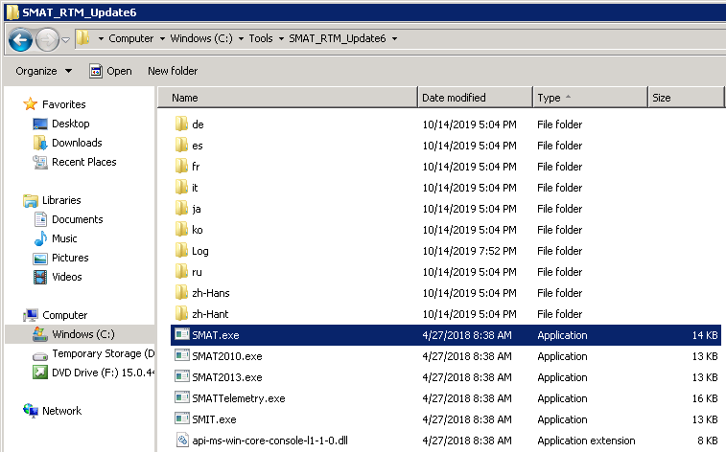**

### Modify SMAT configuration files

There are two configuration files you may want to modify before running the SMAT tool: scandef.json and skipsitelist.csv.

#### Modify Scandef.json file

Edit the **Scandef.json** to control which individual scans are enabled or disabled for the SMAT tool. This is useful if there is a scan you don’t care about and disabling the scan will reduce the overall execution time of the SMAT tool.

1. Open the **SMAT\_RTM\_Update6** folder and right-click the **ScanDef.json** file. Select **Open with…** then click **Notepad** and click **Ok**.
2. Scan through the file and identify any individual scans you want to disable, for example Alerts, CheckedOutFiles, etc. On the scan you want to disable set the **Enabled** property to **false**. Save the file when finished. Keep all scans enabled if there is not a valid reason to disable any. The following example disables the **Alerts** scan:

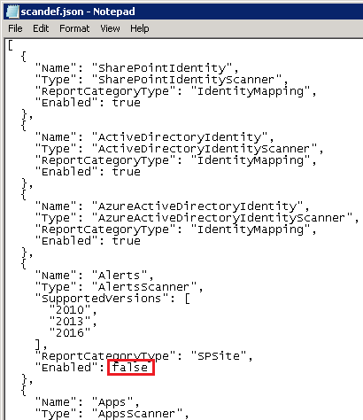

1. For a list of all scanners in the SMAT tool, go to **SharePoint Migration Assessment Tool: Scan Reports Roadmap:** <https://docs.microsoft.com/en-us/sharepointmigration/sharepoint-migration-assessment-toolscan-reports-roadmap>. Click on the individual scanner to learn how to fix issues related to what the scanner is looking at during migration, for example: [Alerts](https://docs.microsoft.com/en-us/sharepointmigration/migration-assessment-scan-alerts).

#### Modify skipsitelist.csv file

Edit the **SiteSkipList.csv** to exclude sites in the report output.

1. Open the **SMAT\_RTM\_Update6** folder and right-click the **SiteSkiplist.csv** file. Select **Open with…** then click **Notepad** and click **Ok**.
2. Add one row for each filter you want to add. Add the URL (http://contoso/sites/legal) and/or a URL pattern, like /personal/. Save the file when finished.

**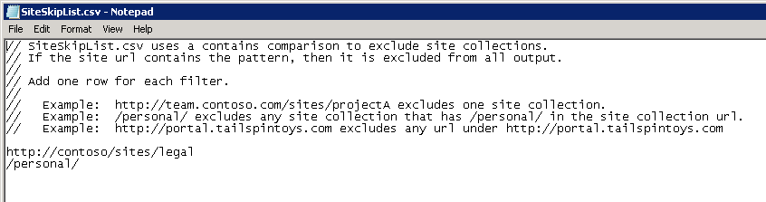**

### Generate Identity Mapping (SMIT)

Use the Identity Mapping feature of the SharePoint Migration Assessment Tool to assist in your Identity Migration.

1. From the SharePoint Server open the **Command** **Prompt** **as** **Administrator**.
2. Change directories to the folder where the SMAT tool was extracted:

cd c:\Tools\smat\_RTM\_Update6

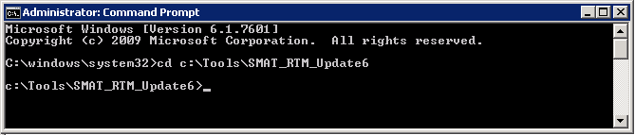

1. Run **SMAT.exe -help** to ensure the tool loads correctly and displays the help content.

smat.exe -help

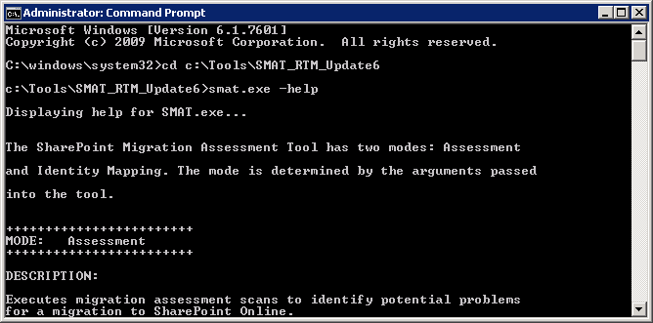

1. Run **SMAT.exe** with **-GenerateIdentityMapping** to perform identity mapping and output the results to a specific folder.

smat.exe -generateidentitymapping -o "c:\Tools\SMAT\_RTM\_Update6\Logs\SMIT1"

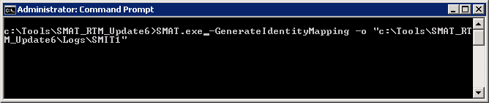

1. Login to your Azure Tenant to validate your account can perform the necessary tasks. In the **Sign-in to your account** window, enter credentials with **Global** **Administrator** role to your target Azure and Microsoft 365 tenant.
2. The SMIT tool will begin running three scans: **SharePoint Identity**, **Active Directory Identity** and **Azure Active Directory Identity**. The three identity scans can be individually enabled/disabled using the scandef.json file. Confirm all three scans completed 100%.

**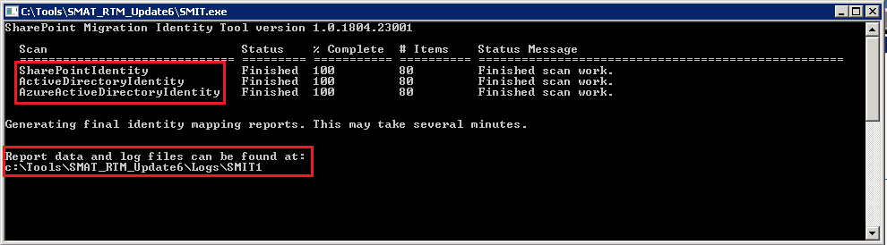**

1. When completed, Press **enter** to close the Command window**.**

### Assess the SharePoint Server farm using SMAT

SMAT is designed to run without impacting your environment, so you may observe the tool requires up to one to two days to complete a scan depending on the size of the environment. During this time, the tool will report progress in the console window.

1. In the event SMIT is still running the identity mapping, open another **Command** **Prompt** **as** **Administrator**.
2. Change directories to the folder where the SMAT tool was extracted:

cd c:\Tools\smat\_RTM\_Update6

1. Run **SMAT.exe** to perform the assessment of SharePoint Server farm and output the results to a specific folder.

SMAT.exe -o "c:\Tools\SMAT\_RTM\_Update6\Logs\SMAT1"

Screen Capture of the command prompt. Running the command 
"SMAT.exe -o "c:\Tools\SMAT_RTM_Update6\Logs\SMAT1""


1. The SMAT tool outputs progress in the window. If you disabled scans you will see the scans are not included (for example the **Alerts** scan was disabled in the image below – so you do not see Alerts in the list). When SMAT completes it will output “**Generating final report… 100%**”.

Screen Capture of the command prompt. Output of the finished SMAT run. 


1. On the **optional** step of entering your SharePoint Online tenant domain URL – click **Y** or **N.**
2. When complete, press **Enter** to close the **SMAT<version>.exe** window.

### Review the SMIT logs and Reports

Review the SMIT logs and reports generated from the scan of Active Directory, SharePoint Server and Azure Active Directory.

1. Navigate to the folder that contains the SMIT Logs from the previous SMIT scan “c:\Tools\SMAT\_RTM\_Update6\Logs\SMIT1”. In the “SMIT1” folder you will find up-to 3 logs:

* SMAT.log
* SMATTelemetry.log
* SMAT\_Errors.logs (if there were errors encountered running the scans)

1. The SMAT log files surface the errors and can be useful, however it is easier to view the error data in the SMIT Report: **FullIdentityReport.csv** using **Excel**.
2. From **Excel** open the **FullIdentityReport.csv** on the **Text Import Wizard – Step 1 of 3** window leave defaults (**Delimited**) and click **Next**.

Screen Capture of the text import wizard in Excel Step 1 of 3


1. On the **Text Import Wizard – Step 2 of 3** window check the box **Comma** and click **Next**

Screen Capture of the text import wizard in Excel Step 2 of 3. With Comma delimiters selected


1. On the **Text Import Wizard – Step 3 of 3** window leave defaults and click **Finish**

Screen Capture of the text import wizard in Excel Step 2 of 3. With "General" under Column Data Format selected.


1. The **FullIdentityReport.csv** is now open in Excel. Use the **Filter** and **Sort** options on the columns: **FoundInAzureAd** and **ReasonNotFoundInAzureAd** columns to easily identify all the user accounts and groups in SharePoint Server not mapped to the Azure Active Directory tenant.

**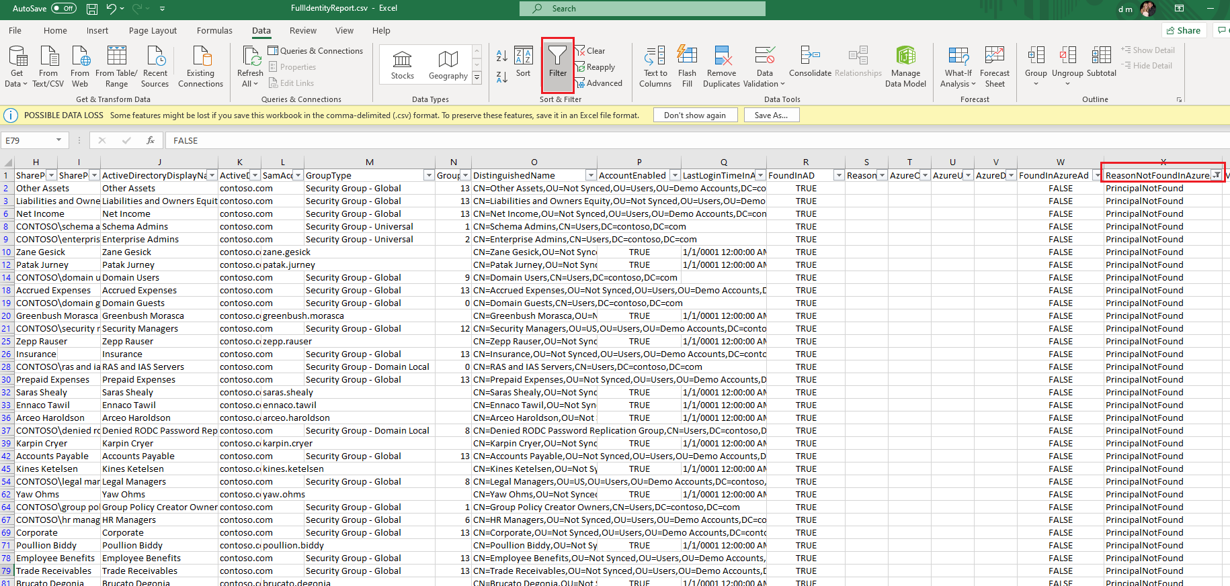**

### Review the SMAT logs

Review the SMAT logs to ensure the scan of the environment was successful.

**Note:**  The SMAT tool may run for one to two days when scanning larger environments. You may have to proceed with the next module and return to this scenario on the following day to proceed.

1. Navigate to the folder that contains the SMAT Logs from the previous SMAT.exe scan “c:\Tools\SMAT\_RTM\_Update6\Logs\SMAT1”. In the “SMAT1” folder you will find up-to 3 logs:

* SMAT.log
* SMATTelemetry.log
* SMAT\_Errors.logs (if there were errors encountered running the scans)

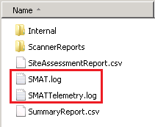

1. The SMAT.log file can be viewed in **Notepad** or with **Excel**. For the best experience, save the SMAT.log as a **.csv** file and open in **Excel**:
2. Copy the SMAT.log and save to a machine with Excel installed.
3. Open **SMAT.log** with **Notepad** and Save the file as **SMAT.csv**
4. Open **Excel** and click **File** then click **Open**. Navigate to the location of the **SMAT.csv** file and click open. The SMAT log file will open organized into five columns: Time, ThreadID, Severity, Category, and Message

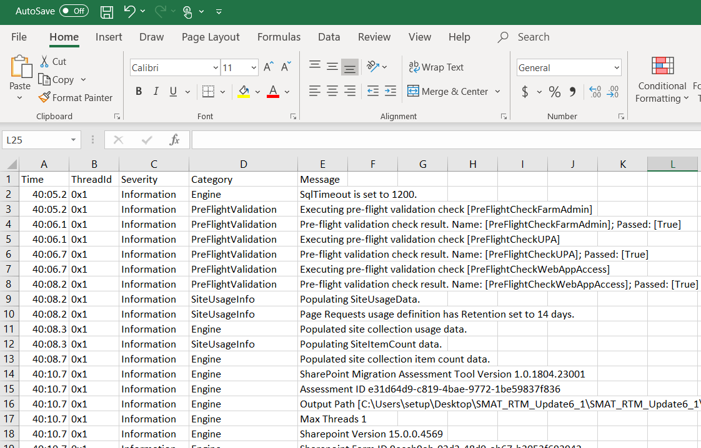

1. Click on the first row of the column **Severity**. In the ribbon click on **Data**, then click on **Sort**.

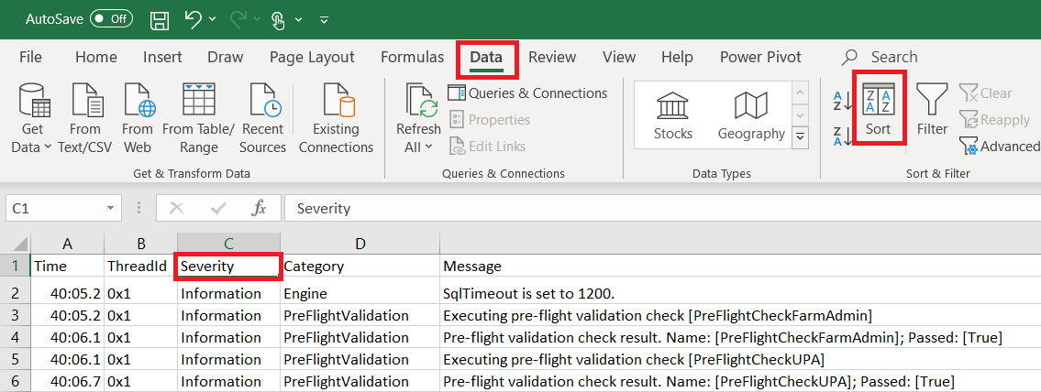

1. In the Sort window select **My data has headers**. In the Sort by drop down select **Severity**, in the Sort on drop down select **Cell Values** and in the Order drop down, select **A to Z**.

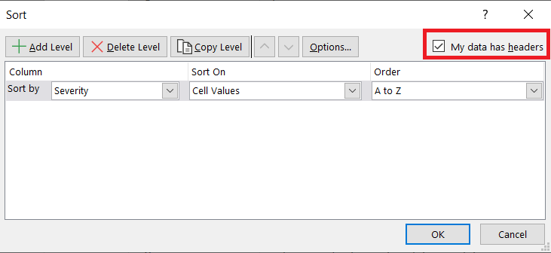

1. With first row of Severity column still select, in the Ribbon click on **Data** and then Click on **Filter**. Click on the dropdown on the **Severity** Column to Sort A to Z, Z to A, or use Filter checks to select **Warnings** or **Errors**.

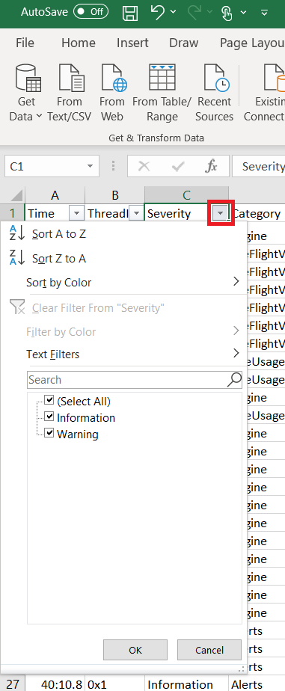

1. Review all warnings and errors in the log.

### Explore the SMAT Reports

Explore the SMAT reports and folder structure to understand what reports are generated and what information the reports contain. Copy the reports folder to a machine with **Excel** installed. Performing an analysis of the issues in the reports will done in a later step.

1. From the SharePoint Server where the SMAT tool is installed navigate to the SMAT tools location: **C:\Tools\SMAT\_RTM\_Update6\Logs\SMAT1**
2. In this folder you will find 2 report files:

* **SiteAssessmentReport.csv** – Detailed breakdown of each site collection and information about the site.

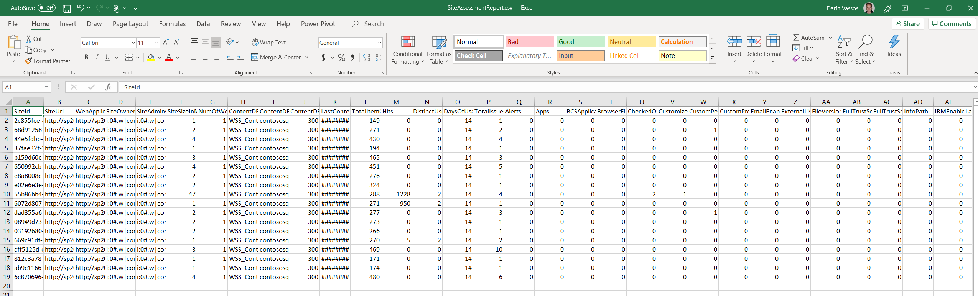

* **SummaryReport.csv** – High-level summary of the farm and issues found

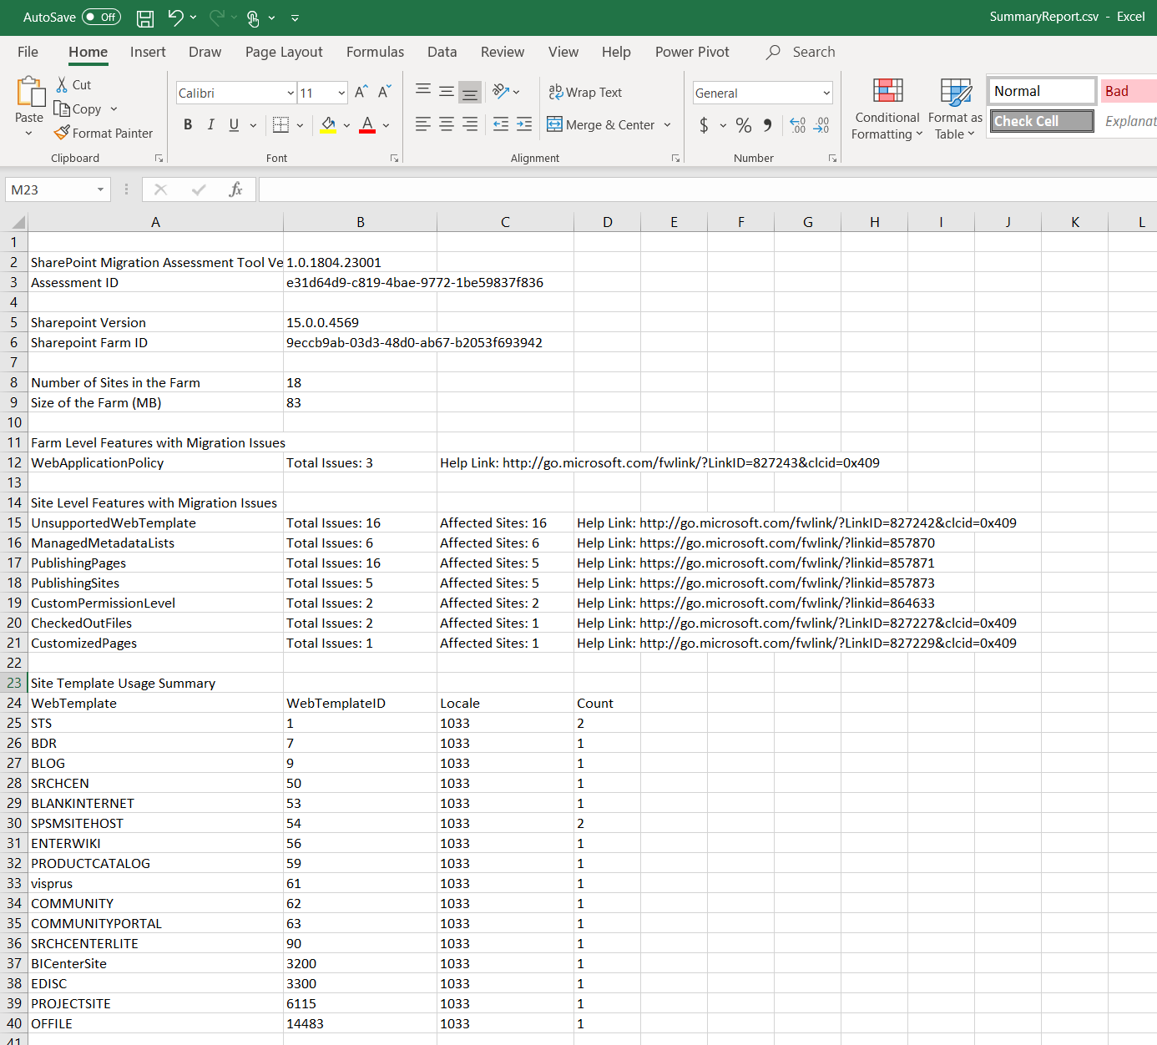

1. Detailed reports can be found in the **\ScannerReports** subfolder in the output root folder. The detailed reports provide detailed information about issues that arose during the assessment of the SharePoint Server farm while running the SMAT tool. There may be up to 31 detailed reports per farm, depending on what issues where encountered during the scan.

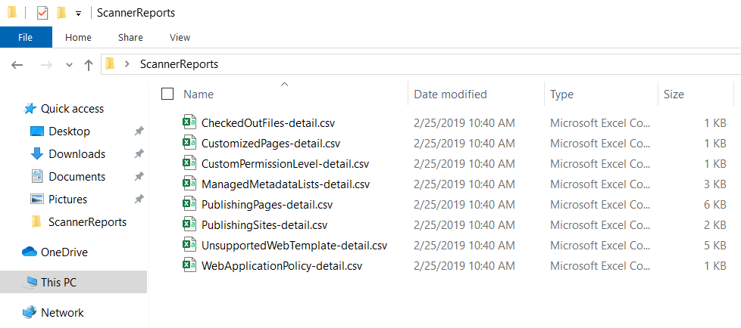

1. Copy the **SMAT1** folder to a machine with **Excel** (or add to a .zip and copy to the target machine).

**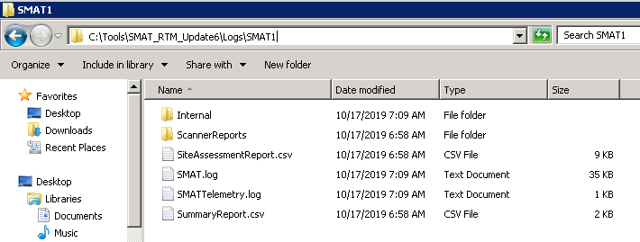**

#### Merge the SMAT Reports

Merge the SMAT scanner reports and summary report into a single workbook using the Microsoft FastTrack tool: SMAT Workbook Generator. For more information see: <https://github.com/Microsoft/fasttrack-smat-workbook-generator>

1. Log onto to the machine that you copied the **SMAT1** reports folder to in the previous step.
2. Download the latest release of the **SMAT** **Workbook** **Generator** tool: <https://github.com/Microsoft/fasttrack-smat-workbook-generator/releases>



1. **Unzip** the file. It contains the **smatwb.exe** as well as supporting files and DLLS.
2. You may need to "unblock" the files after downloading depending on your system settings. **Right-click** on the **smatwb**.**exe** file. In the Properties screen of the file, under the **General** tab, look for a **Security** message. If you see the **Unblock** option, check the box then click **Apply**.

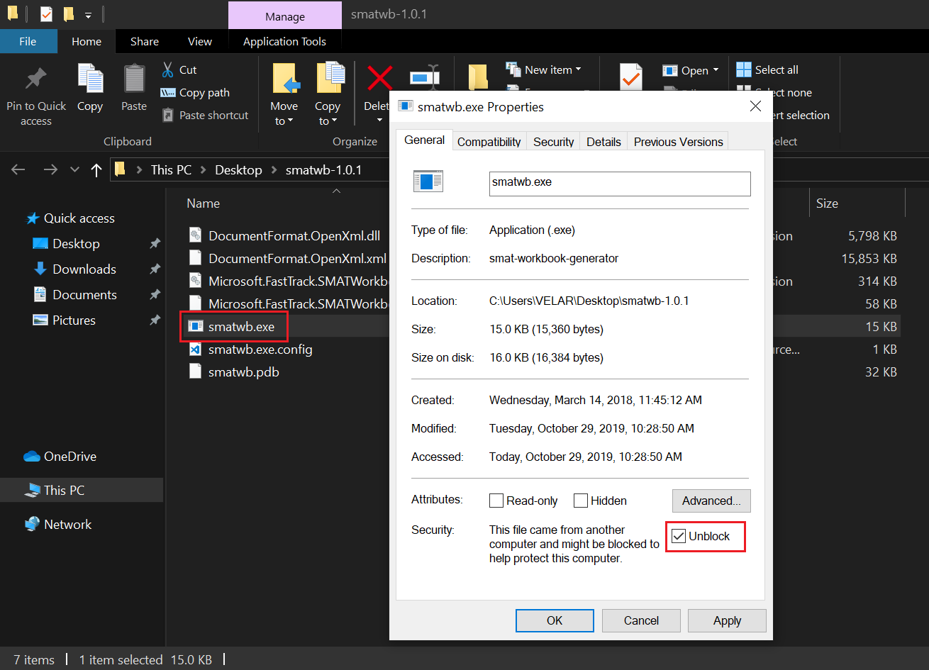

1. This tool runs on the command line and takes several parameters as described below. Open a **Command** **Prompt** as **Administrator.** Change directories to the folder that contains the **smatwb**.**exe** file:

Screen Capture of the command prompt. Changing the directory to the smatwb-1.0.1 folder.


1. Run the **smatwb**.**exe** tool and specify the source folder. The **-s** argument takes the path to the root of the SMAT1 folder. This is the folder containing the "**SummaryReport.csv**" file:

smatwb -s "c:\path\to\SMAT1"

Additional optional parameters to specify:

**Specify the workbook output folder:**

smatwb -s "c:\path\to\SMAT1" -o "c:\path\to\write\mergedworkbook\"

**Specify template name**

smatwb -s "c:\path\to\SMAT1\output" -t Simple

1. Wait for the command to complete. **Press any key to exit.**

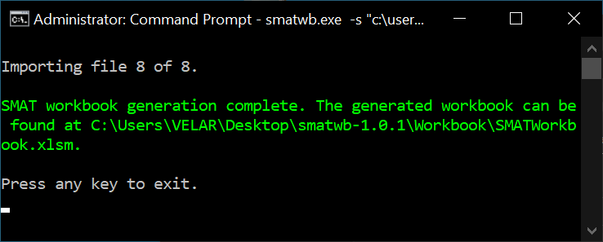

1. Navigate to the folder containing the **smatwb**.**exe** folder. There will be a new sub-folder called **Workbook**. Open the folder and find the merged workbook: **SMATworkbook.xlsm**

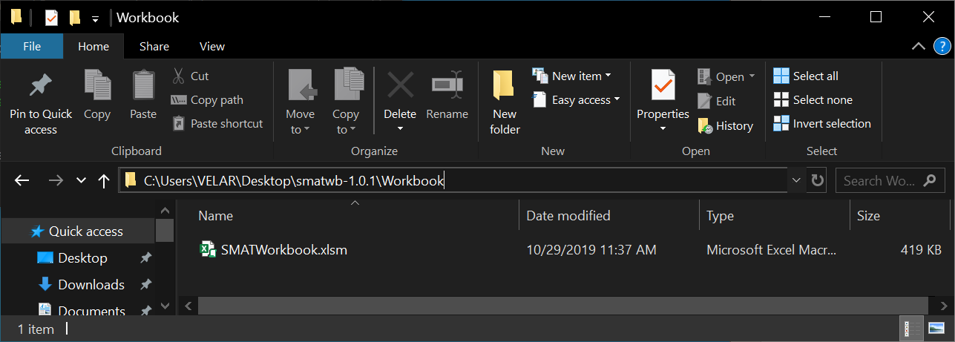

#### Review the merged SMAT Report in Excel

Review all findings from the SMAT reports using the merged report generated in the previous step.

1. Open the **SMATworkbook.xlsm** with Excel.
2. In the **SECURITY WARNING Macros have been disabled** banner click the button **Enable** **Content**.

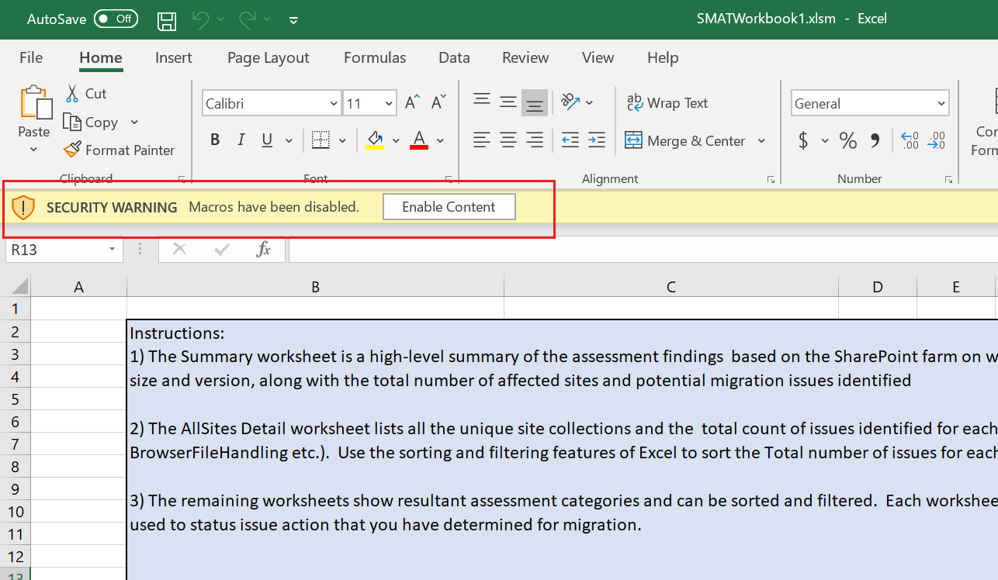

1. On the **Instructions** tab, review the instructions and worksheet color legend. Click on each worksheet tab to review the details from the SMAT report.

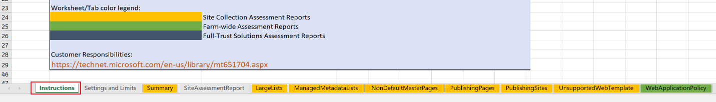

1. For additional help understanding the individual scanner reports, go to the **Scan** **Reports** **Roadmap**: <https://docs.microsoft.com/en-us/sharepointmigration/sharepoint-migration-assessment-toolscan-reports-roadmap>.
   * The Scan Reports Roadmap provides the following guidance for each scanner report:

* Overview
* Data migration
* Preparing for migration
* Post migration
* Scan result reports (describes the information returned by the scan)